EMPOWER – File Upload User Documentation

Contents

Initial Build Upload 2

Updated Builds Upload 2

# Initial Build Upload

* Once you have finished creating the game using the editor, you then need to upload the files to a web server to make the files accessible to the Client version.
* 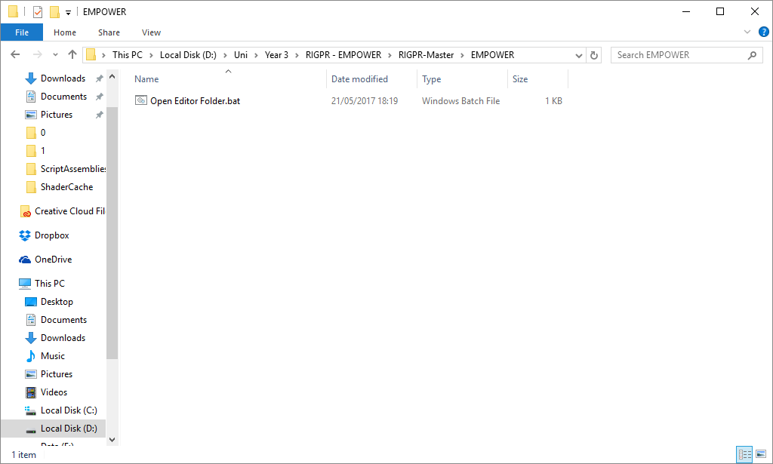To locate the files, find the file called “Open Editor Folder.bat” and double click it.
* 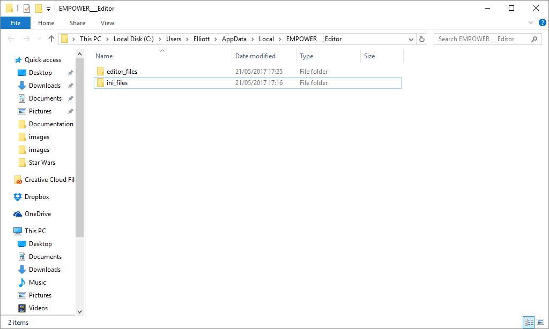Once open, you will be present with two folders.
* 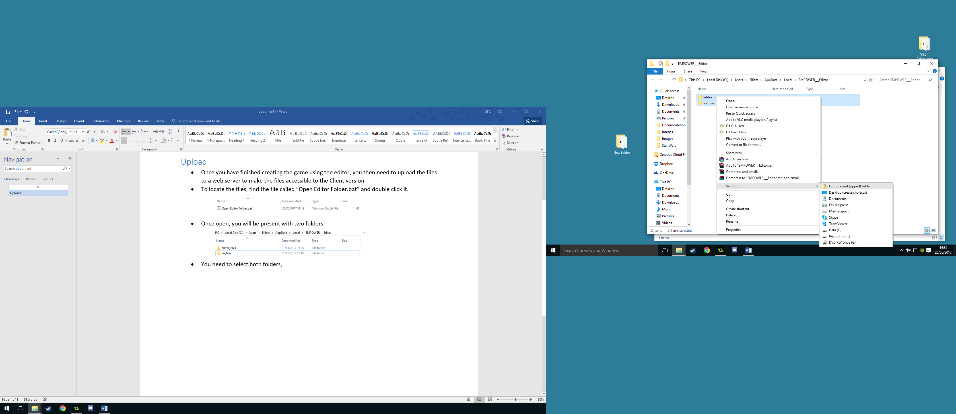You need to select both folders, then Right Click on the “editor_files” folder and select “Send To” and then “Compressed (zipped) folder”.
* 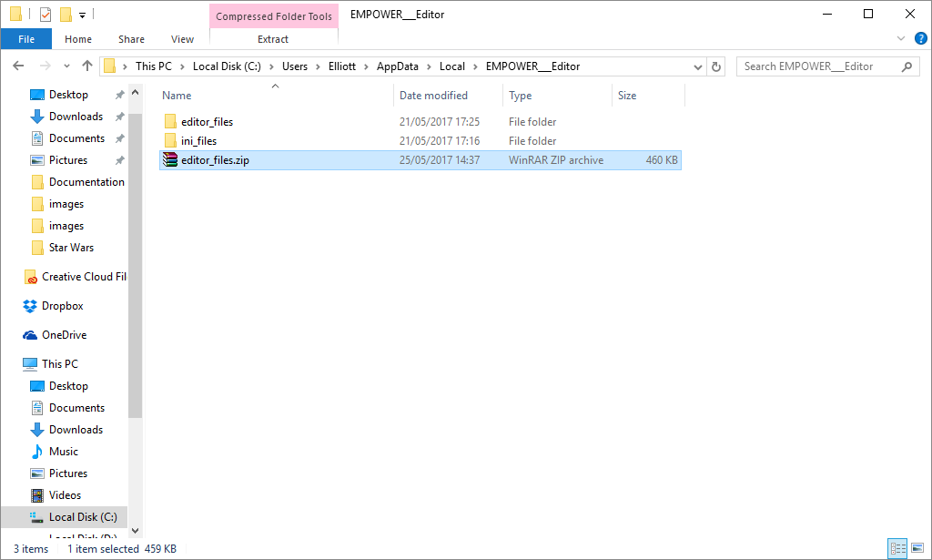This will create a zipped file called “editor_files.zip”, if the file is not called editor_files (if you Right Click on ini_files above, it will be called “ini_files.zip”), you will need to rename it.
* Once this file has been created, you need to upload the file to the webserver. The web address must point to the “editor_files.zip” file, when the client is first started, it will ask for a web address, if it can find the file it will download and install it.

# Updated Builds Upload

* The process is almost exactly the same as the Initial Build Upload process, however, you must also upload the “Update.ini” file that is created when you use the “Push Update” (Options > Push Update) feature within the Editor.